**FOR OFFICE USE ONLY**:

Signed?

On repeat meds?

Date registration received: ……………………………

Checked by: …………………………………………..

***Barcellos Family Practice: New Patient Questionnaire***

Welcome to the Barcellos Family Practice. To accurately register you at the surgery please fully complete this questionnaire in full. Please note your registration cannot be accepted until the forms are completed in full. Thank You.

***Personal Details:***

|  |  |  |  |  |
| --- | --- | --- | --- | --- |
| **Title** |  | **Surname** | |  |
| **Forename** |  | **Middle Name(s)** | |  |
| **Previous Surnames**  **(if applicable)** |  | **NHS Number** | |  |
| **Date of Birth** |  | **Marital Status** | |  |
| **Gender** | Female  Unable to answer | Male  Prefer not to say | | Non-Binary |
| **Is your gender the same as the sex you were assigned at birth?** | Yes  Unable to answer | No | | Prefer not to say |
| **House/Flat Number** |  |  | |  |
| **Street** |  |  | |  |
| **Town** |  |  | |  |
| **County** |  |  | |  |
| **Postcode** |  |  | |  |
| **Key Safe Number?** |  |  | |  |
| **First line of previous address (incl Postcode)** |  |  | |  |
| **Home Telephone** |  | **Mobile Telephone** | |  |
| **Email Address** |  |  | |  |
| **Next of Kin** |  |  | |  |
| **Relationship to you** |  |  | |  |
| **Next of Kin Telephone Number** |  |  | |  |
| ***We need to have your consent to begin communicating with you by text or email.***  *Please confirm your consent by ticking to accept the options below:*  *I consent to the practice contacting me by text message or email for the purposes of health promotion, practice news and for appointment reminders.*  *I acknowledge that appointment reminders by text are an additional service and that they may not be sent on all occasions but that the responsibility for attending appointments or cancelling them still rests with me.*  *Text messages are generated using a secure facility, but I understand that they are transmitted over a public network onto a personal telephone and as such may not be secure.*  *I understand I can cancel the text message facility at any time.* | | | | |
| **Name and address of previous GP** |  |  |  | |
| **Country of Birth** |  | **Date entered the UK**  **(if not UK born)** |  | |
| **Ethnicity** | British or mixed British  African  Indian  Bangladeshi  Other (please state) |  | Irish  Caribbean  Pakistani  Chinese | |
| **Religion** | C of E  Buddhist  Sikh  No religion | Catholic  Hindu  Jewish  Other: | Other Christian  Muslim  Jehovah’s Witness | |
| **Employment** | Employed  Unemployed | Self Employed  Homeless | Student  Housebound | |
| **Overseas Visitor?** | Yes No | **Do you hold an EHIC card (European Health Insurance Card)?** | Yes No | |
| **Have you ever served in the armed forces?** | Yes No | Family Member has served |  | |

***Communications:***

|  |  |
| --- | --- |
| **Main spoken language** |  |
| **Interpreter or special communication needs?** | Yes No  If yes, please specify detail: |
| ***Are you an unpaid carer? If so, please provide details below:*** | |
| **I care for (name)** |  |
| **Relationship to you** |  |
| **Would you like to be added to the Practice Carer Register?** | Yes No |
| ***Do you have a designated carer? If so, Please provide details below:*** | |
| **Name of Carer:** |  |
| **Contact:** |  |

***Your Medical History: Please list all current or past illnesses/operations including dates, where possible:***

|  |  |  |  |
| --- | --- | --- | --- |
| **Heart Disease/Angina** |  | **Diabetes** |  |
| **Epilepsy** |  | **High Blood Pressure** |  |
| **Stroke/TIA** |  | **COPD** |  |
| **Asthma** |  | **Cancer** |  |
| **Dementia** |  | **Hyperthyroidism** |  |
| **Other:** |  | | |

***Family History: Please list all significant medical conditions that your close family members have and please state their relation to you:***

|  |  |  |  |
| --- | --- | --- | --- |
| **Heart Disease/Angina** |  | **Diabetes** |  |
| **Epilepsy** |  | **High Blood Pressure** |  |
| **Stroke/TIA** |  | **COPD** |  |
| **Asthma** |  | **Cancer** |  |
| **Dementia** |  | **Hyperthyroidism** |  |
| **Other:** |  | | |

***Do you have any known allergies? (E.g. antibiotics, food, bee sting, latex)***

|  |
| --- |
| Yes: No: If yes, please state: |

***Repeat Medications (If applicable):***

|  |  |
| --- | --- |
| ***Drug name:*** | ***Dose:*** |
|  |  |
|  |  |
|  |  |
|  |  |
|  |  |

***Alcohol use disorders identification test consumption***

|  |  |  |  |  |  |  |
| --- | --- | --- | --- | --- | --- | --- |
| Questions | Scoring System | | | | | Your Score |
| 0 | 1 | 2 | 3 | 4 |
| How often do you have a drink containing alcohol? | Never | Monthly or less | 2 to 4  times per month | 2-3 times per week | 4 or more times per week |  |
| How many units of alcohol do you drink on a typical day when you are drinking? | 0 to 2 | 3 to 4 | 5 to 6 | 7 to 9 | 10 or more |  |
| How often have you had 6 or more units if female, or 8 or more if male, on a single occasion in the last year? | Never | Less than monthly | Monthly | Weekly | Daily or almost daily |  |

*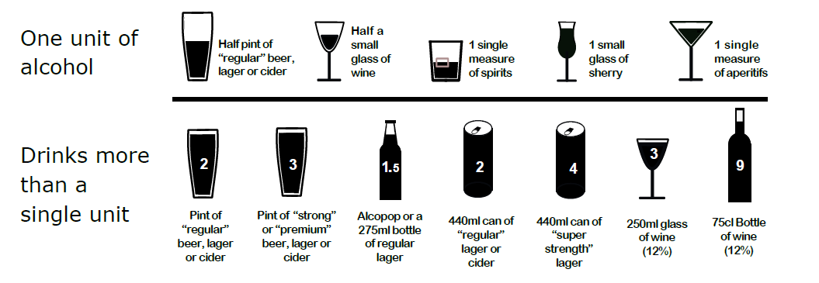****Scoring:***

● A total of 5 or more is a positive screen

● 0 to 4 indicates low risk

● 5 to 7 indicates increasing risk

● 8 to 10 indicates higher risk

● 11 to 12 indicates possible dependence

If your score is 5 or more, you can complete a full audit C screening test here <https://tinyurl.com/y9nu8nh5>

For help about alcohol please call us or visit [www.nhs.uk/live-well/alcohol-support](http://www.nhs.uk/live-well/alcohol-support)

***Smoking Status (Please tick one box only)***

|  |  |  |  |
| --- | --- | --- | --- |
| **I am currently a smoker** |  | | |
| **I have never smoked** |  | | |
| **I am an ex-smoker** |  | | |
| **I use an e-cigarette** |  | | |
| **How many cigarettes do you/ did you smoke a day?** | Less than one  1-9 | 10-19  20-39 | 40+ |
| **Would you like help and information to stop smoking?** Yes: No: | | | |

***Health Information:***

|  |  |  |  |  |  |
| --- | --- | --- | --- | --- | --- |
| **Weight**  ***(st/lbs. or kgs)*** |  | **Height**  ***(ft./” or metres)*** |  | **Blood pressure** |  |

***Women’s health:***

|  |  |
| --- | --- |
| **Are you currently, or think you might be pregnant?** | *Yes: No:* |
| ***Estimated Date of Delivery if pregnant (EDD)*** |  |

**Electronic Prescription Service:** The practice can send your prescription to your preferred pharmacy electronically. If you have previously nominated a pharmacy in another area and you now wish to change to a local pharmacy, **please inform us of your preferred pharmacy:** .

***Patient Participation Group:***

|  |  |
| --- | --- |
| **Would you like to become a member of the PPG?:** | *Yes: No:* |
| *The Barcellos Family Practice Patient Participation Group (PPG) is formed of people from a variety of backgrounds, who each bring something different to the group. Its members are volunteer patients who work with the managers and clinicians at the Practice to support and promote the best possible health care for all patients.*  [*https://www.barcellosfamilypractice.co.uk/patient-participation-group*](https://www.barcellosfamilypractice.co.uk/patient-participation-group) | |

***Organ Donation***

With effect from 15 March 2020, organ donation in England moved to an **'opt out'** system. This means that ALL adults in England will be considered to have agreed to be an organ donor when they die unless they have recorded a decision not to donate or are in one of the excluded groups.

Your family will still be approached and your faith, beliefs and culture will continue to be respected.

You still have a choice about whether or not you wish to become a donor.

Please go to the organ donation website for more information: [**www.organdonation.nhs.uk**](http://www.organdonation.nhs.uk)

***Consent & Data Sharing:***

***If any of the details on this form change in the future, please inform us***. In accordance with the Data Protection Act, the Practice needs consent from any patient for us to leave a message, send a text or information regarding their medical treatment. By providing the information on this form you are consenting to be contacted about your medical needs. The Barcellos Family Practice uses SystmOne clinical software. This enables us to share your record with any other NHS organisations who are involved in your healthcare.

***Data Sharing Consent Choices (Summary Care Record & Dorset Shared Record)***

To maintain continuity of clinical care, we upload **certain** medical information so that it is available to other healthcare organisations (e.g. Emergency Departments). Please read the accompanying leaflet which details which part of your record is extracted and how it is used to help other NHS organisations.

If you wish to **OPT OUT,** **please tick:**

***Online Services***

If you have provided an email address above, you will be **automatically registered** for online services with the Practice through **‘SystmOnline’** (incl. prescription requests, booking (select) appointments amending your demographic details and access to your medical records).

If you wish **to opt out, please tick:**

Signed ______________________________ Date: _____________________